AllerJanuary is a national awareness campaign led by Julian Edwards of Allergen Accreditation, encouraging food businesses to pause, reflect, and strengthen their approach to allergen management. With Food Hypersensitive (FHS) customers continuing to grow in number and influence, having clear, robust allergen systems in place is now essential for safety, trust, and commercial success.

To support AllerJanuary and beyond, Food Allergy Aware has produced a FREE AllerJanuary Round-Up Resource Pack, bringing together practical guidance, tools, and training to help embed best practice across hospitality, healthcare, education, and care settings.

What’s included in the AllerJanuary Resource Pack?
The pack is designed to be practical and usable, not theoretical. It includes:
- Allergen awareness and education tools covering the 14 allergens, hidden allergens, cross-contact, and Free From claims
- Practical coffee shop guidance, including STOP THINK best practice
- Top 10 allergen tips for kitchens and front-of-house teams
- Free webinar links covering labelling, hospital catering, coffee shop risks, and equipment insights
- Fact sheets, supplier directories, and links to allergen-aware recipes to support inclusive menu development

From Awareness to Action
Beyond awareness, the pack includes real-world implementation tools to support day-to-day operations, such as:
- Effective use of allergen matrices (and why they should never be used in isolation)
- Guidance for event catering, where risk is increased by volume and last-minute changes
- Clear advice on positive communication with FHS customers following a risk assessment
- Why asking customers to sign disclaimers is not legal, does not remove duty of care, and can seriously damage trust
- The importance of near-miss reporting to improve training and prevent incidents
- PPDS labelling best practice and managing ingredient changes over time
- An overview of digital tools and software that support accurate allergen data, menus, and labelling
These tools help businesses move from intention to action.

Upskilling Chefs: Free From Cookery Masterclass
Food Allergy Aware’s Free From Cookery Masterclass (9–10 March 2026) provides hands-on training for chefs to:
- Understand allergen risk during preparation
- Prevent cross-contact in busy kitchens
- Create inclusive menus without compromising quality or creativity
- Build confidence when catering for multiple and complex allergies
Upskilling chefs is one of the most effective ways to improve allergen safety while unlocking the commercial potential of the Free From market.

Find out more:
https://foodallergyaware.co.uk/events/free-from-cookery-masterclass/

Certification Pilot Scheme
For businesses ready to go further, Food Allergy Aware’s Certification Pilot Scheme offers Bronze, Silver, Gold, and Platinum levels, assessing:
- Policies and documentation
- Staff training and knowledge
- Communication with customers
- Supplier controls
- Kitchen procedures and service delivery
Early adopters benefit from additional support and recognition as leaders in allergen management.

Why a Robust Allergy Policy Still Matters
At the heart of effective allergen management is a clear, well-implemented allergy policy. A policy must be supported by robust procedures, regular training, and clear communication between front of house and kitchen.
A strong allergy policy:
- Clarifies roles and responsibilities
- Supports consistent decision-making
- Protects customers and staff
- Demonstrates due diligence
- Reduces legal and reputational risk

AllerJanuary Is More Than a Campaign
It’s an opportunity to review, refresh, and strengthen allergen management so that safer, more inclusive dining becomes the standard, not the exception.
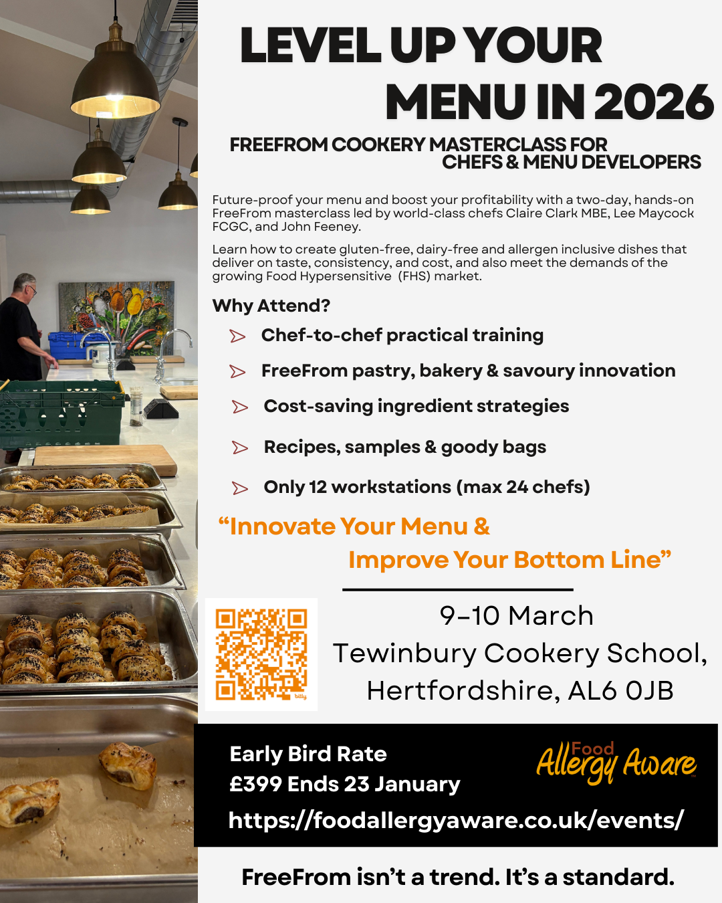

Download the FREE AllerJanuary Round-Up Pack via the Food Allergy Aware blog and start your 2026 allergen review with confidence. Link

